Zeta Group - Siddarth Konduru, Devon Myers, Matthew Meehan

**Design Project 2: Bop-It! Project Final Report**

**Design Overview**

The purpose of this design project was to provide an alternate spin on the Bop-it game. Some of the things we deliberated in the design phase included the shape and size of the enclosure as well as the inputs we would choose. At the start, our design was dependent on three main inputs, a joystick, an accelerometer, and a touch sensor. Furthermore, we were going to initially have an enclosure design with handles on either side (as seen in Fig. 1) and a wider design in general, but we figured it would be more ergonomic to make it more compact. 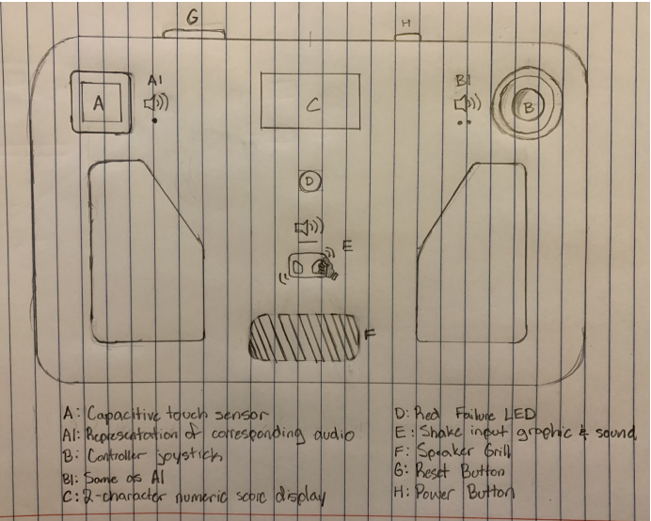

*Fig. 1. First design of the enclosure for the Bop-It Project*

As for inputs, we considered things such as a motion sensor or a switch that needs to be flipped, but we figured that a touch sensor and joystick would be more intuitive and thematically consistent for the user.

The next design to review is the schematic for our project. The first schematic is shown in Fig. 2 and has the inputs and outputs for our joystick, touch sensor, and accelerometer. The schematic contains the two decoders that are required to have for the hex displays and our voltage regulator. It also has all three inputs, which are actually 5 since the joystick had 3 inputs itself, and all ground connections as well. It is connected through. All of our connections are through net labels which makes it easier to see what pin connects to each input and output. It also makes for a cleaner look to the schematic.

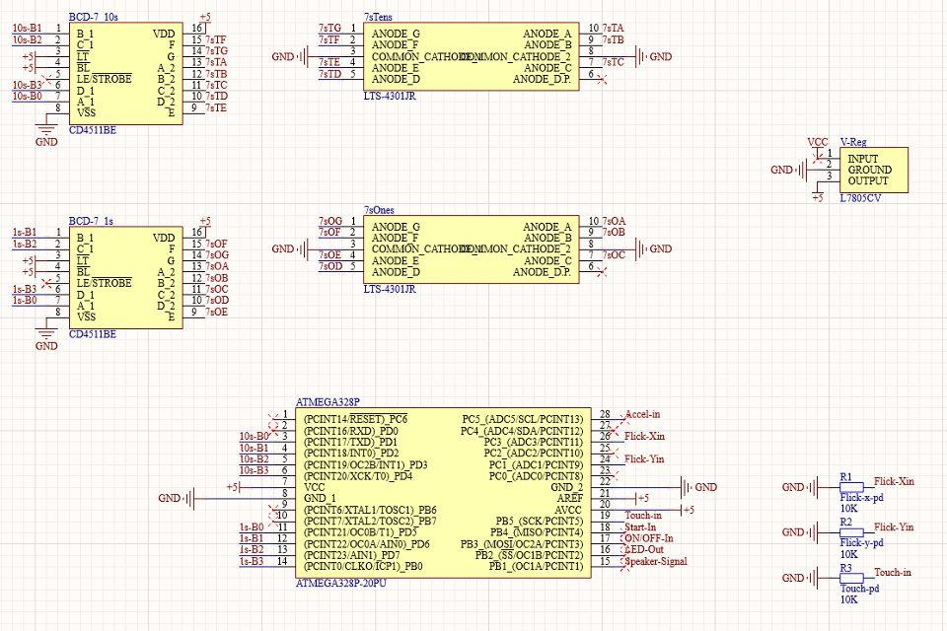

*Fig. 2. First circuit schematic of our Bop-It project*

Since this was our first schematic, we had found out that components were missing that should have been there. Components such as pull down resistors as well as our crystal oscillator and two capacitors that go with the crystal oscillator. In Fig. 3 you can see our final schematic with the correct components added.

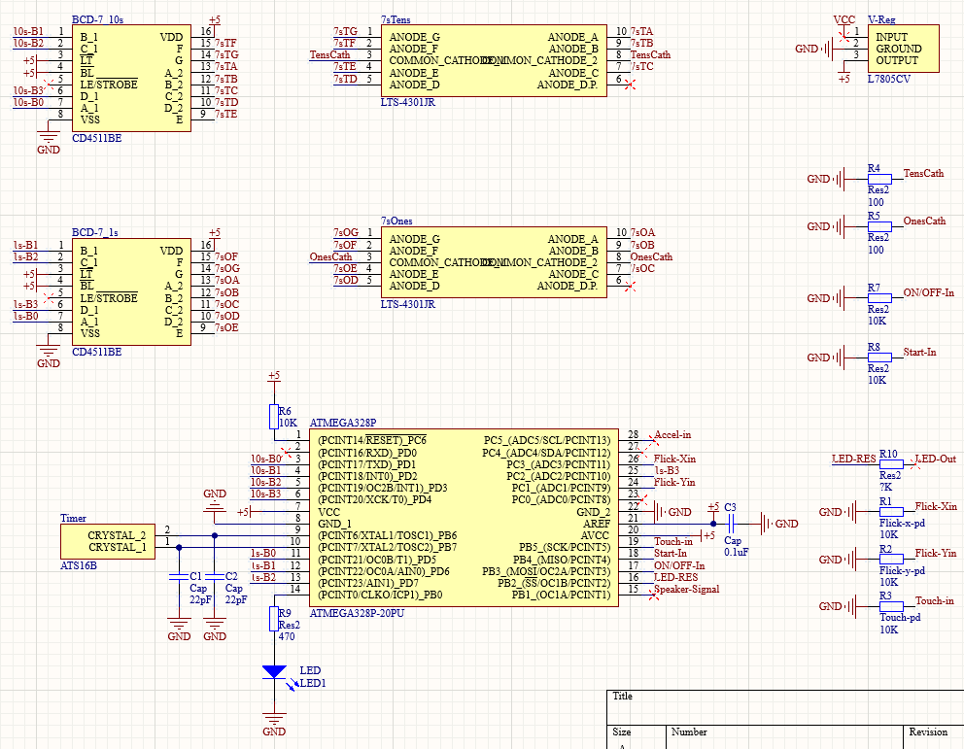

*Fig. 3. Final schematic of our Bop-It Project.*

Figure 4 is the final PCB schematic for our project. It is the third board to be manufactured and is slightly larger than the original 2 designs. This occurred due to a misunderstanding our group had about the operation of the ATMEGA device and its requirements. After adding the extra pull down resistors, capacitors, and crystal oscillator, the board was far too cramped to fit on the original, very small size. Although the general layout of the board remained the same, a few changes were implemented that made construction much cleaner and easier. The vias placed around the perimeter of the board were reorganized to match the layout of the ports on the breakout boards for each input and they were moved further from the edge in order to make soldering easier.

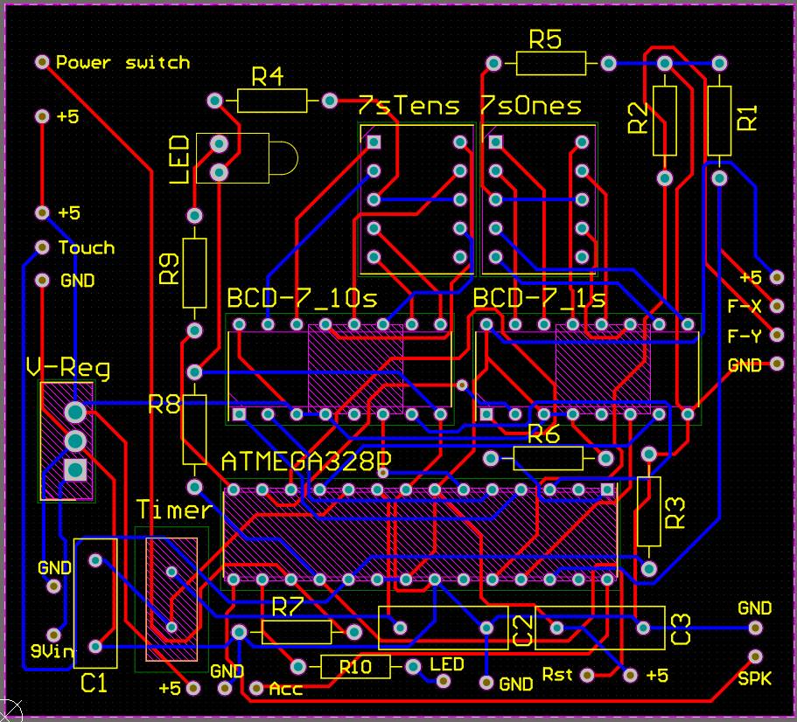

*Fig. 4. Final PCB design of the schematic for the Bop-It Project.*

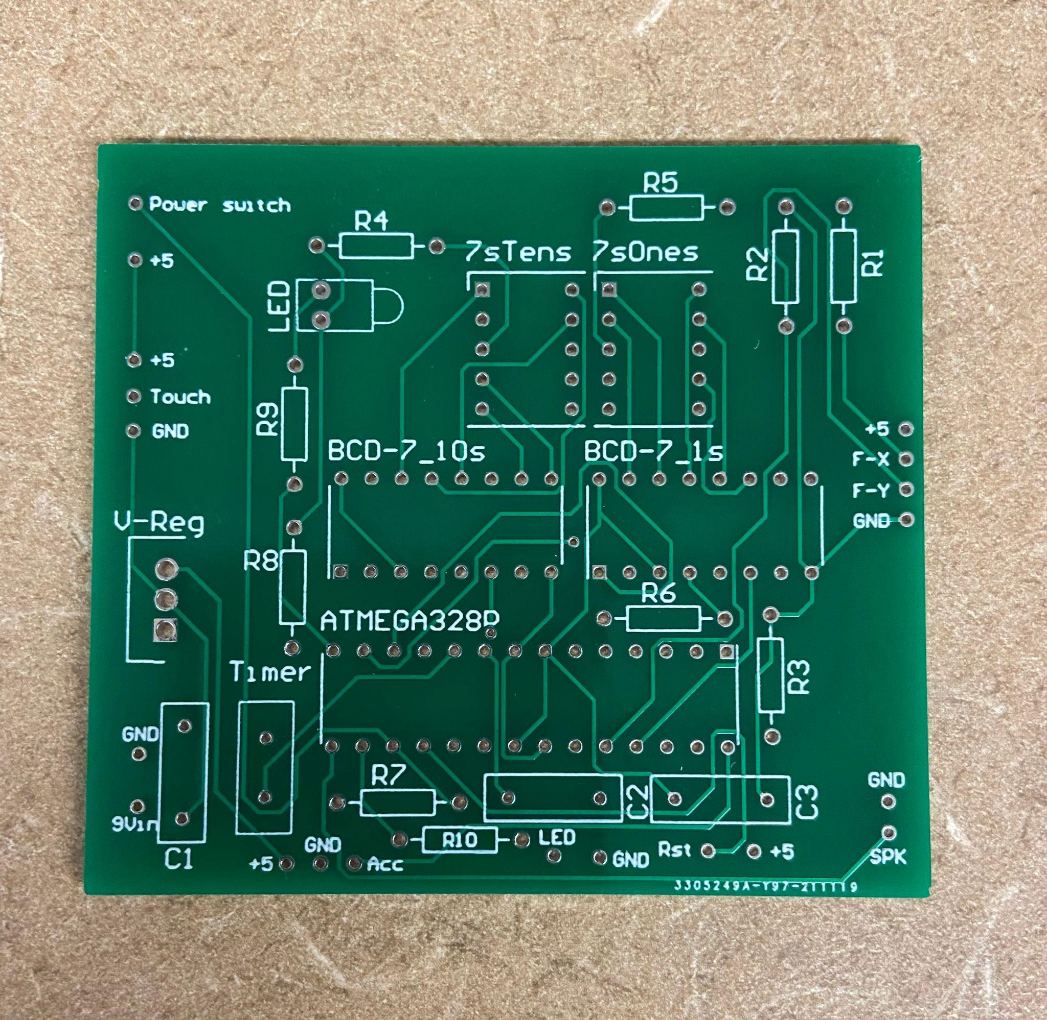

*Fig. 5. Physical PCB for the Bop-It project.*

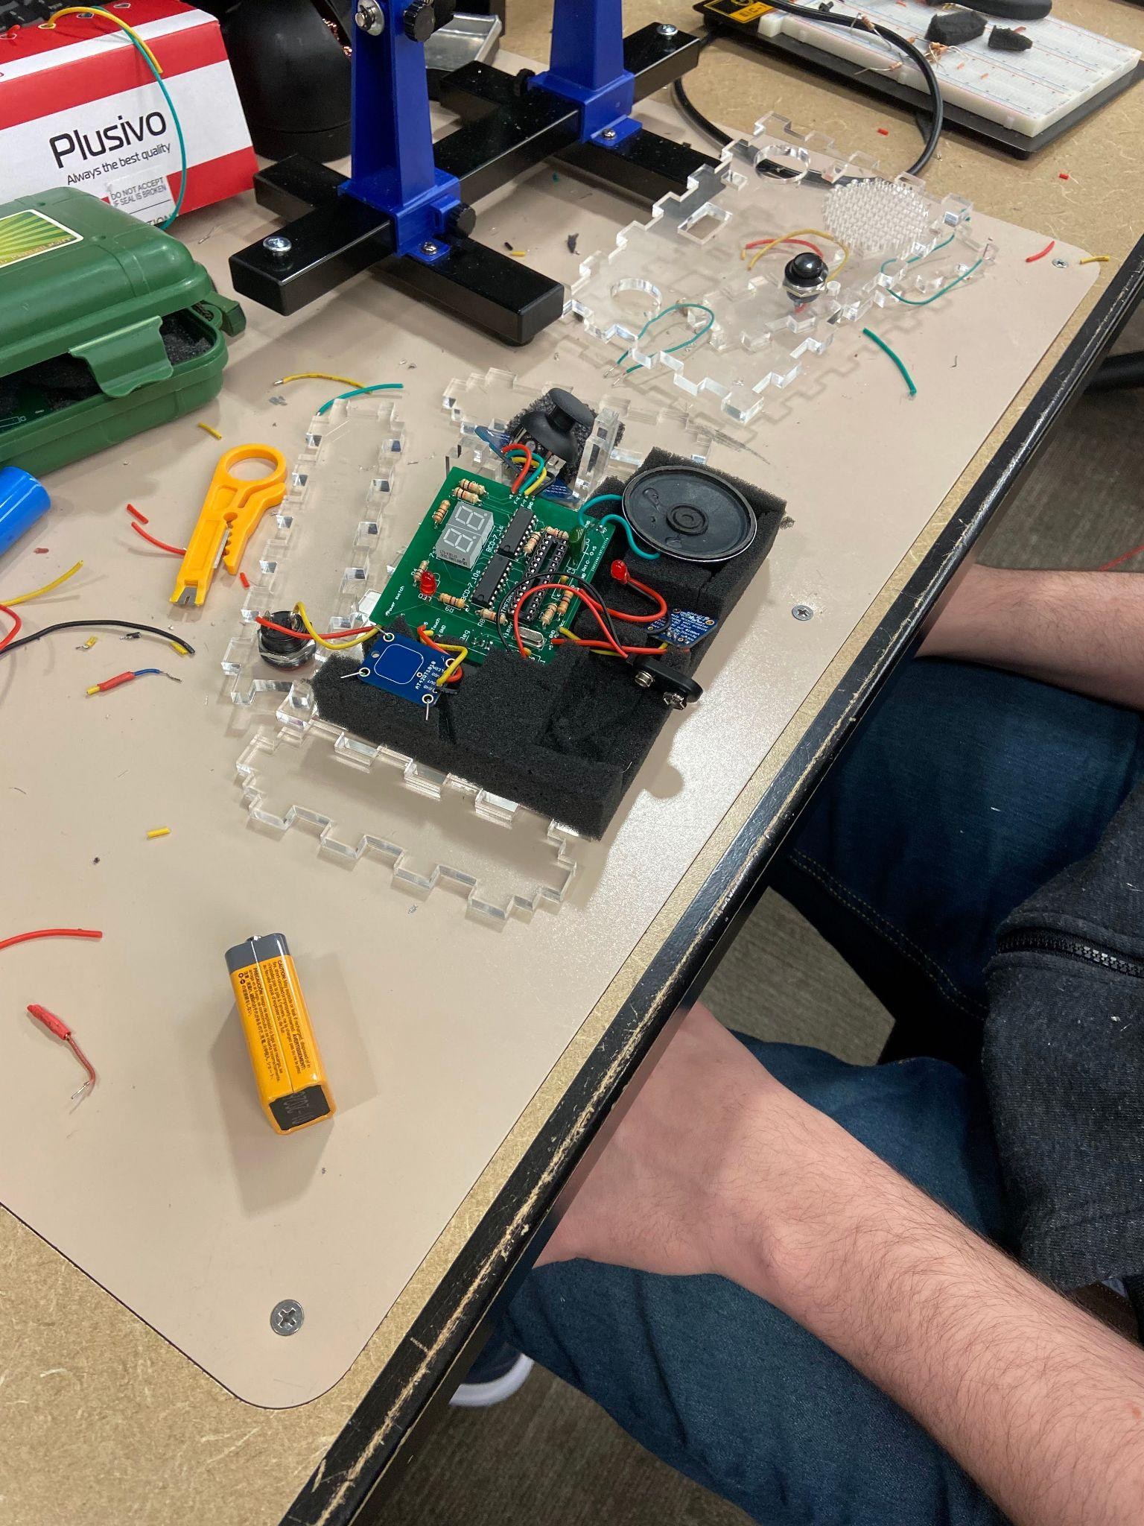

*Fig. 6. System integration of Bop-It project.*

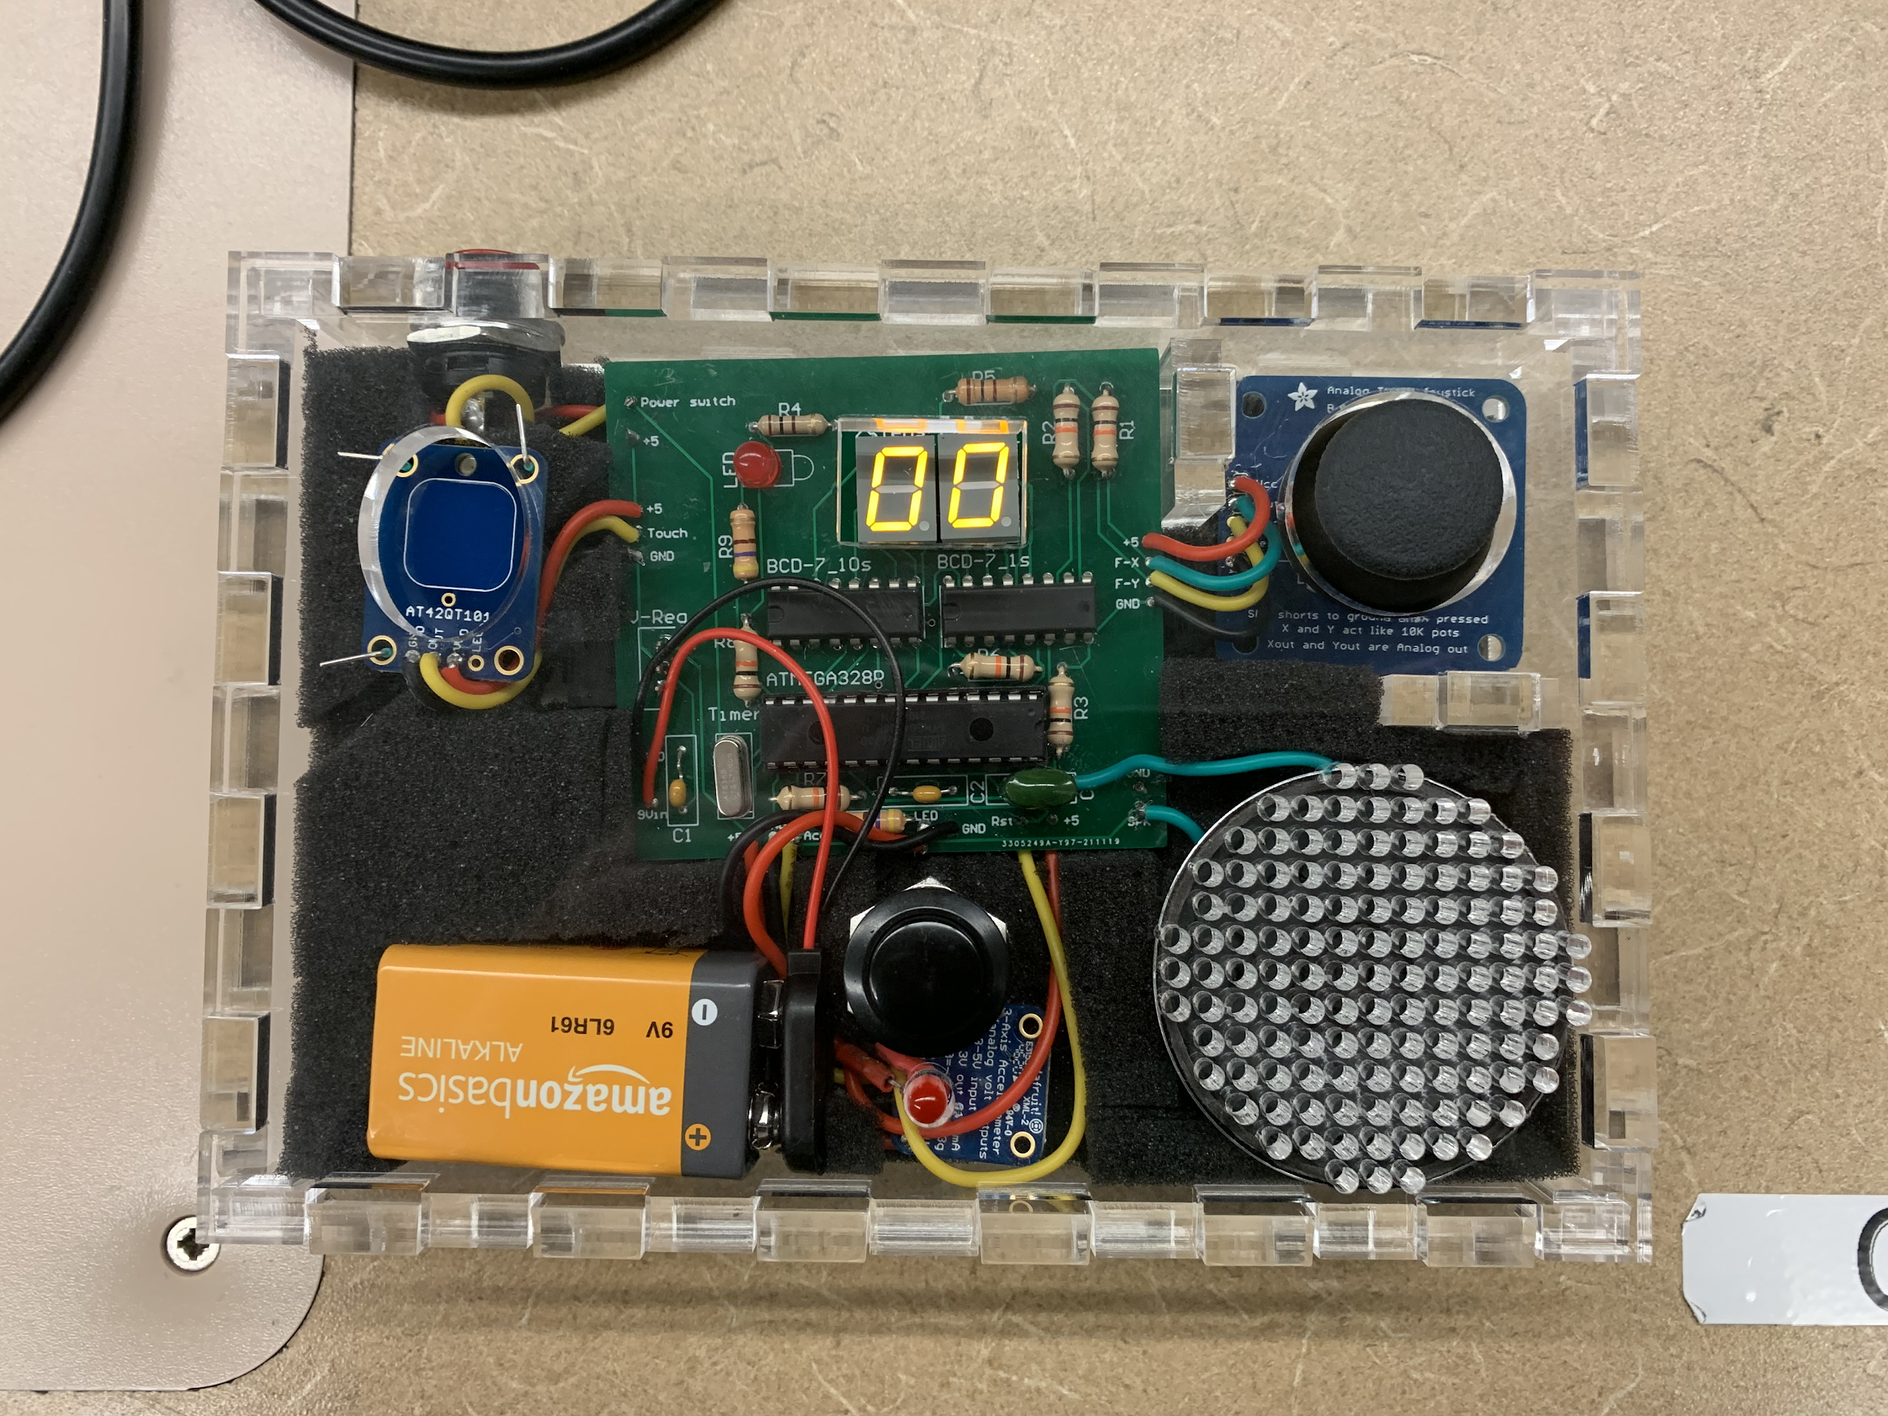

*Fig. 7. Final Bop-It design in the enclosure*

**Design Verification**

We went about testing our design by checking components individually on a breadboard while connected to the mega chip; we used a speaker to indicate what was going on internally in the code. We tested our inputs first to ensure that they were functional and that they were returning voltage to the chip. We then moved on to checking the inputs with the code to make sure that the code was working as intended.

During our testing, our hex displays were not properly functioning and we had to re-order new hex displays. The problem was something within the component and was displaying our score with faulty lines and in strange colors as well. Another component we had to re-order was our accelerometer because the only way to access the z-axis output of the accelerometer was to use software that we could not implement in the project.

**Electronic Design Implementation**

For our electronic component design, we made the decision to utilize input components from adafruit that came on their own breakout boards. This was done for two main reasons. First, utilizing breakout boards would allow us to quickly change between input methods if need be. Secondly, board size was a concern for us since the device is handheld and the breakout boards included very small surface mount components required for the input operation that would have been difficult to include as readily solderable components onto the board. In a similar vein, in order to save space on the board, we decided to use a single larger resistor on the common cathode of each 7 segment display instead of onto every pin. This was done to allow our board to only contain 1 resistor per display instead of needing 7. We also included a 5 volt regulator since all of our components were able to be driven safely by 5 volts but 9 volts was too high.

Electrical component placement was largely dictated by where we desired the input or output to be in the enclosure. This is why the ATMEGA was placed centrally on the board and why things such as the pulldown resistors and voltage regulator were placed on the edges where they would have only short wire connections to the actual input.

**Software Implementation**

The way the code works is by having multiple nested if statements, which effectively act as while loops thanks to the fact that the chip constantly loops through the code. It constantly polls for the power button being pressed, if it is not, then the code does nothing. Once it is pressed a boolean is set to true and the code can now proceed to the next level of the code. From here, the code parses constantly for the start button being pressed, and likewise does nothing when it is not. When it is pressed however, the code moves into the input section where the user is given a random game to play based on the audio cue. Each game works by checking for the user’s input for 3 seconds by running through a for loop 3000 times with a 1 ms delay in each cycle, and it will give a unique audio cue based on whether or not the user was successful. If successful, the score will increment and it will return to the top of the loop; if unsuccessful, the game will stop and display the final score until the user starts the game up again. Once the user hits a score of 99, the game will also stop and display the user’s score.

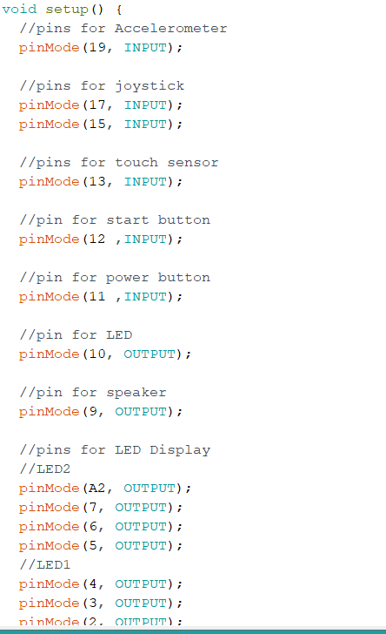

*Fig. 8. Pin connections in Arduino code.*

**Enclosure Design**

The first enclosure design requirements for our project was to have holes for two buttons, an LED, the touch sensor, two hex displays, the joystick, and multiple holes for the speaker to act as a grill. We wanted the overall size of the enclosure to be small enough to be considered a handheld device, almost that of a Nintendo Switch. 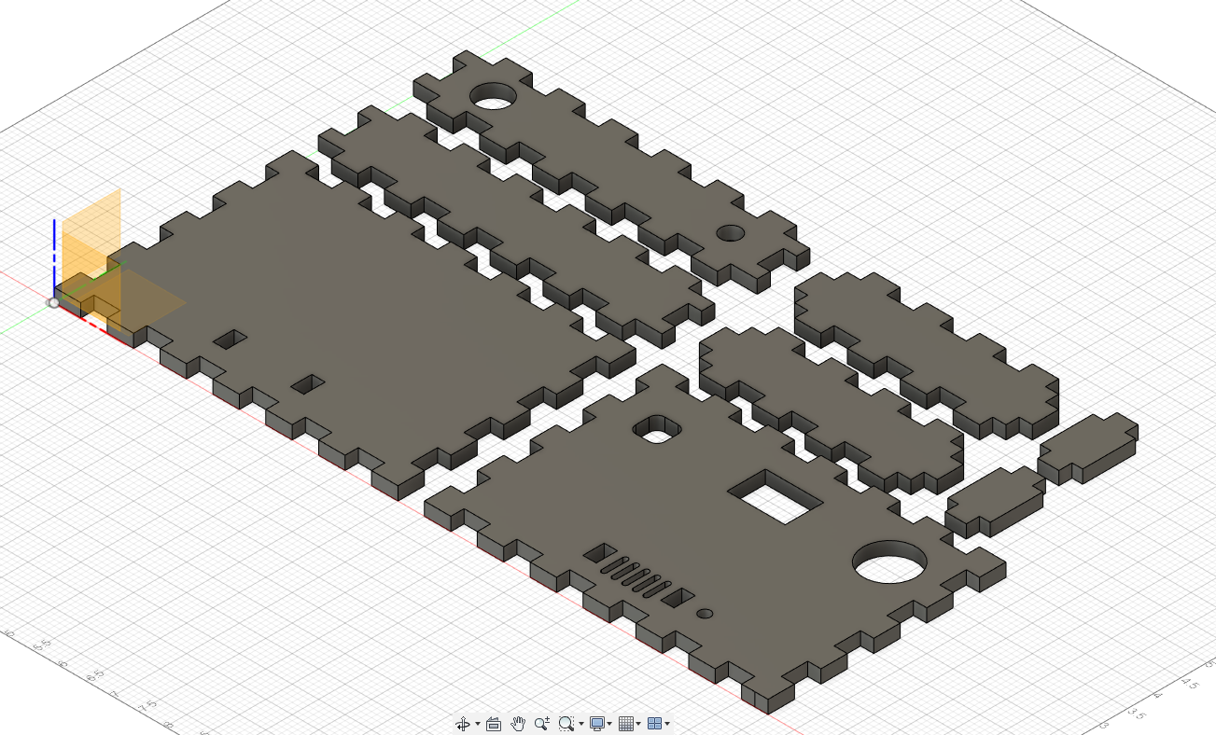

*Fig. 9. First lifted enclosure design*

At that point we wanted the joystick on one side and the touch sensor on the other so it would have the feel of holding a controller to a gaming console. The display for the score of the Bop-It needed to be visible while playing so putting it in the middle of the front facing side was our best option along with the LED for losing the game was on the front face of the game. 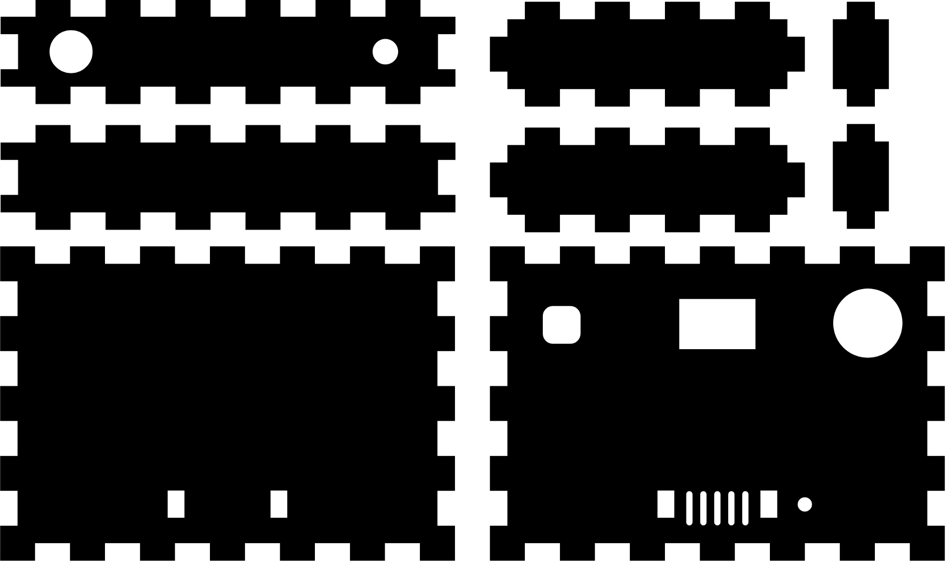

*Fig. 10. First design of enclosure as svg file*

Above is our first design for the enclosure, with the power button and play button on the top of the enclosure. After consideration, the design was changed so that the play button would be on the front of the game, and the buttons would be different colors. The speaker grill also was placed at a difficult position on the board where we could not place the speaker in front of it, so that was another design change during our process.

Below is our finalized enclosure with the correct grill in the right place and the start button to the game is located in the center middle with an error LED. Another implementation is two small walls on the inside of the structure surrounding the joystick so when the user flicks the joystick, it will not move in the interior of the box. An alternative solution would be to hot glue the component down, but we did not want to risk any damage to the component. We also needed to increase the size of the hole for the touch sensor since we realized a thumb could not fit inside the original hole.

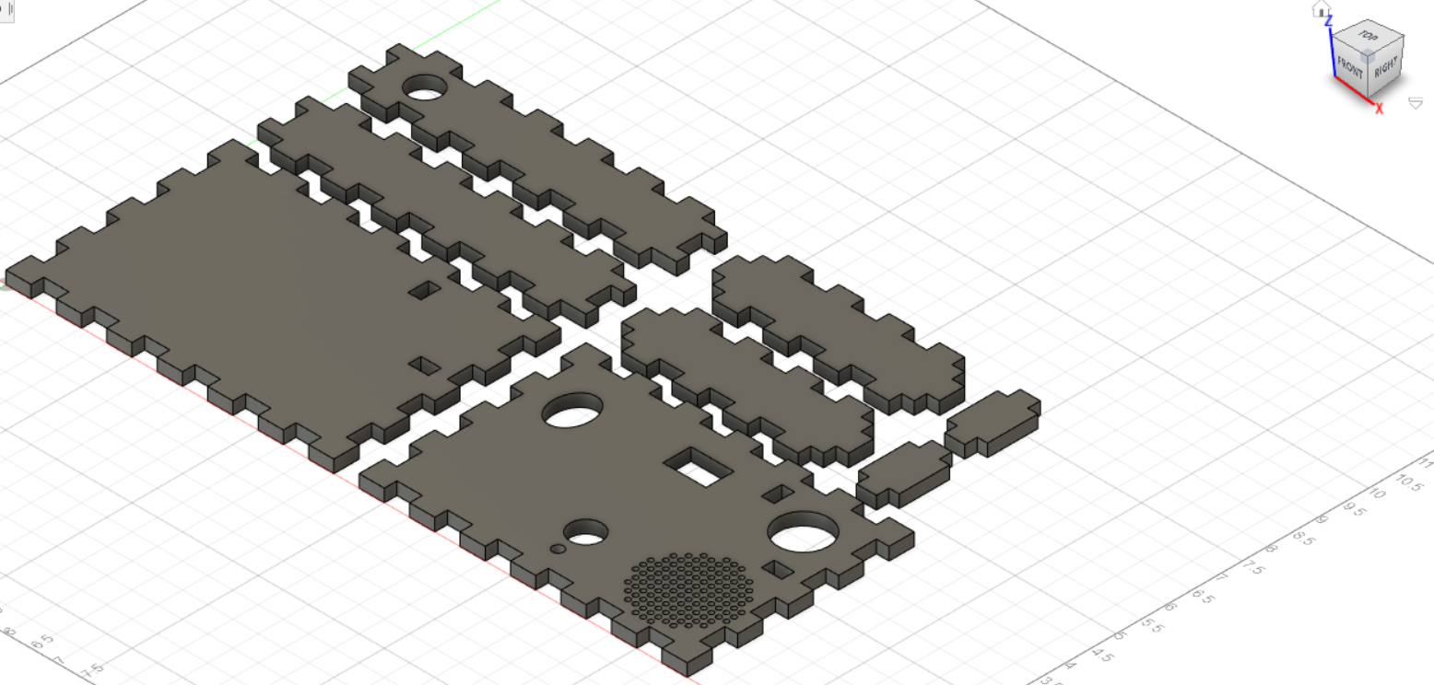

*Fig. 11. Final lifted enclosure design*

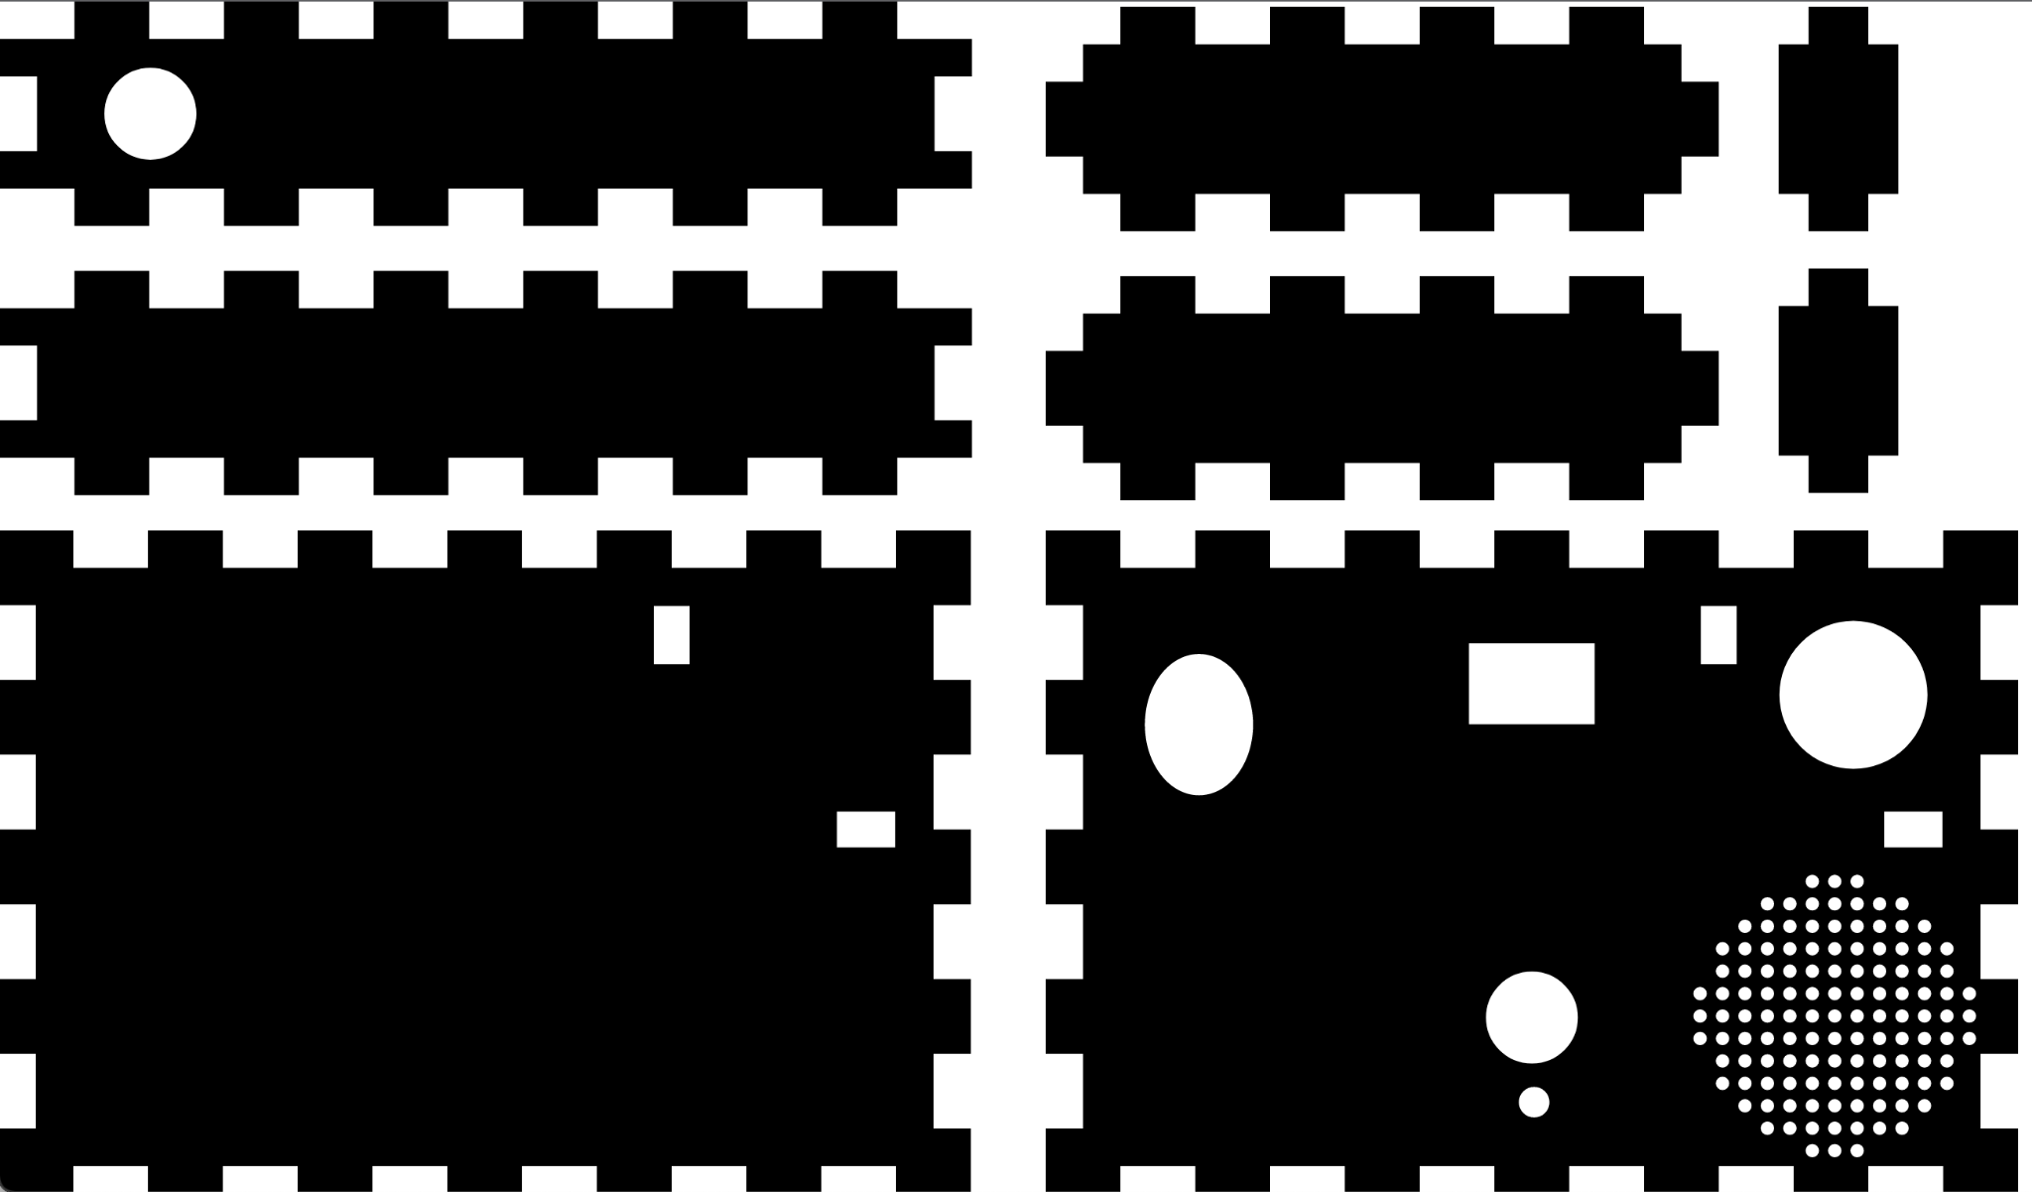

*Fig 12. Final svg file for enclosure*

**Assembly and System Integration**

Assembling each component onto the PCB was at first a disaster. We had soldered each component on without testing the overall PCB or each component on the PCB while soldering. Once every component was on our PCB, the capabilities of our circuit were failing half of the time. After hours, we found out that there was a connection between our power source and the ground terminal. We continued to take out components and test it again and discovered that our accelerometer was the problem. After taking that out, we found it functioning, but throughout the process of removing and re-inserting our components, we ruined multiple connections in the circuit leading us to implement our entire circuit into another PCB.

In the next PCB, we carefully soldered on our components and even replaced a couple components just to be sure that our circuit was “refreshed”. After soldering all the components needed to run the code on the AT-MEGA, we powered it up and the functionality started working. That was the end of the problem with the PCB board and soldering, thank god.

Putting our finalized PCB into the enclosure took us to pre-determine where each input component must go. Since our components must be at specific parts of the enclosure, we had to measure the lengths and cut our wires accordingly. To keep the components from moving, we had to carefully cut into a piece of foam to where the components snuggly fit into the foam structure. This will allow the user to shake the enclosure without damaging the components on the inside. Two components, the power button and start button, must be a part of the enclosure before soldering it onto the PCB so we had to pre-emptively attach those components to the enclosure and solder them once the testing and full design was finished. 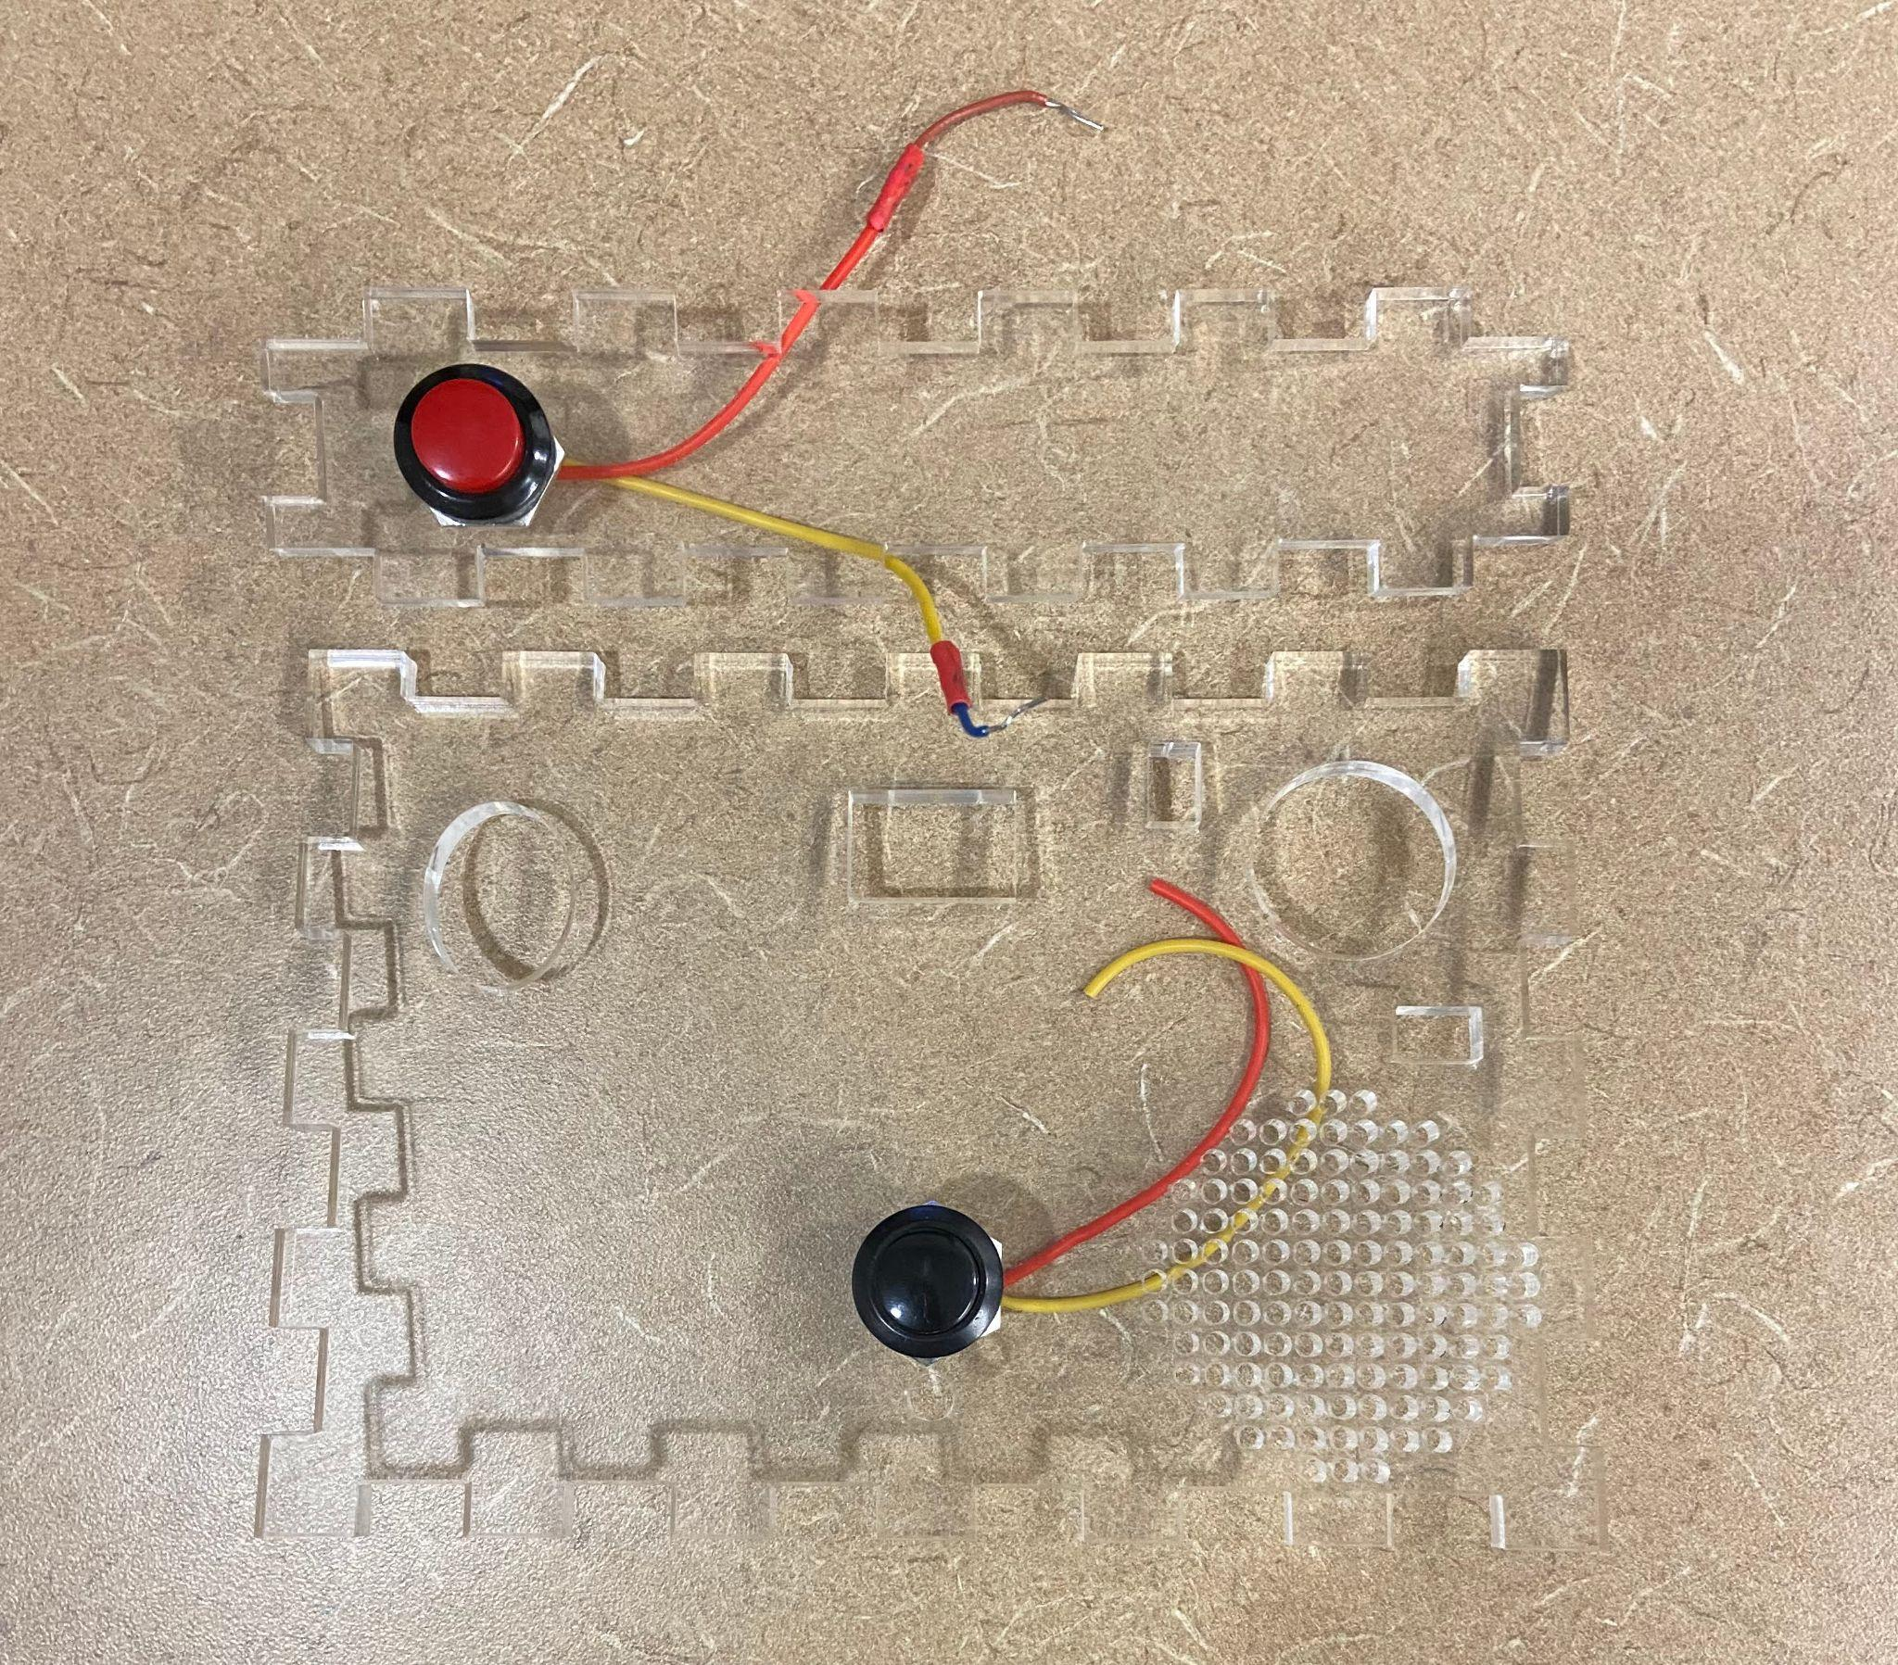

**Design Testing**

Our test plan was to test all the inputs individually while on the board and check to make sure that it was being properly handled when true or false. We used the speaker to indicate whether or not a test case ended in success or failure. Our tests had many failures along the way, with inputs not behaving properly, the board being inconsistently powered, and inputs not being received by the chip. We fixed most of these issues by soldering all of our components to a different board, as for the other issues we tested out the components with different code implementations and used a multimeter to see what the input was doing. The singular issue left with our design is that the display does not change its output even when the score goes up. We exhaustively tested this issue to find the cause and it seems to be down to some quirk in the way the hardware and software interact.Both the hardware and software on their own seem to be perfectly functional. We tested various implementations of the code to see how the LEDs worked, we could get them to display any value we wanted at the start, but changing them from that value never ended up working. The software seems to be correct as well, it tracks the score properly as can be seen in one of our videos where we set the winning score to be 5 and the devices plays the winning sound in response to it. The algorithm to set the value also seems to be correct; we were concerned about the mod function being used to calculate each digit, but even testing it with a static int didn’t fix the problem.



**Budget and Cost Analysis**

Assembly cost and board production cost quotes****

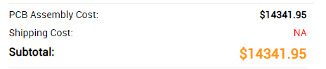

laser cut quote from [https://www.ponoko.com/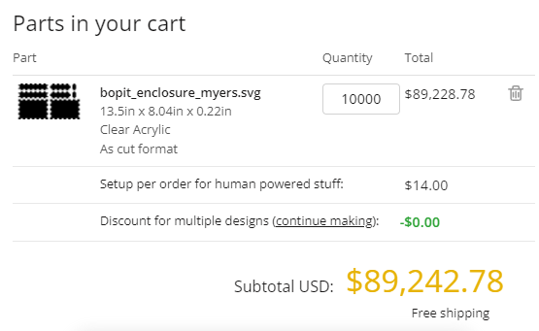](https://www.ponoko.com/*)

Component costs were calculated using digikey with the highest bulk buy discount available (usually 10k units) and adafruit market prices for the breakout boards.

Component estimation: 10,000 * $34.71pu = $347,100

joystick $6

accel $15

touch $6

button x2 $2

atmega $3

display x2 $0.86

bcd to 7 x2 $0.64

crystal timer $0.16

Resistor x9 ~$0.04

capacitor x3 ~$0.15

speaker $0.86

Total Per unit cost to produce 10,000 units: ~$45.35

Total Production cost: $453,515

**Team**

* Devon: PCB Design, Enclosure Design, Project Assembly, Soldering
* Matt: Code debugging, soldering, wiring
* Sidd: Arduino code, code debugging, board testing

Our team worked together both in and out of class. We worked on things that could be done individually separately, while meeting up to work on more important things together. To communicate, we mostly used Groupme.

**Timeline**

* Proposed our designs
* Decided which designs we would use
* Created the enclosure design
* Created the Altium schematic and pcb design
* Created the code for the chip
* Printed the enclosure
* Sent the pcb off to be printed
* Started testing our components on a breadboard
* Realized our schematic did not include the circuit that the atmega chip requires in order to function so we revised it and had it reprinted
* We needed to have it reprinted again to add minor additions like pulldown resistors
* Tested the components on the pcb itself and revised the code with our findings
* Resoldered our components onto a different board because the old one was having issues
* Continued tested and refined our design until it worked consistently and had most of its issues ironed out

**Summary, Conclusions, Future Work**

In summary, our project was almost entirely a success, sans the issue with the display. We set out to make a unique take on Bop-it with different inputs and design. If we were to revise the design we would use a different method of displaying the score to ensure that it works as intended. We would also make it more visually apparent which audio cue corresponds to which input, right now we only know which is which simply because we made it. We could add a little speaker icon to the outside of the enclosure with 1-3 dots under each input to show which is which. We could also make it so the power button actually disconnects the battery and turns off the display; as it stands, the power button is merely a formality since it is needed in order to start the game, but does not actually influence whether the battery is in use or not.